The Alan James Creative Artist Bursary and Residency Programme 2020/21

Application Form
Lead Applicant’s Details
Name of artist(s)
Contact address

Postcode
Telephone
Email
Artist(s) website/social media links

Links to sound or video files - please note this is mandatory, applications will not be considered without access to your music.

Who are you?
Please list and give a brief CV of the artists involved in the residency.

Proposal
Please outline the creative idea you wish EFDSS to support (500 words max)

How would EFDSS support benefit your creative development? (150 words max)

What are the potential future developments for the results of the residency?
(200 words max)

Proposed Timetable
Please note that we may not be able to accommodate your precise dates at Cecil Sharp House so flexibility will be very helpful.

Proposed Budget
Artists’ fees

Travel costs

Accommodation costs

Other Expenses (please identify)

Income – if your budget exceeds £2000, please identify where the additional funding will come from eg other grants, donations, own funds

Amount £ Funder Confirmed/ Not Confirmed

Payment
The bursary will be paid in two instalments: 80% of the grant will be paid on signature of offer letter; the balance will be paid on submission of a report which will be required within one month of completion of the project.

Dates and submission details

Deadline for completed applications Monday 1 June 2020
Applicants will be informed of the outcome by Wednesday 1 July 2020 at the latest.
All residencies to be completed by 28 February 2021
Completed applications should be returned to:-
Zoe Nicol, Artistic Programme Co-ordinator, zoe@efdss.org

Funded by individual donations and grants from
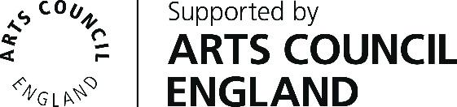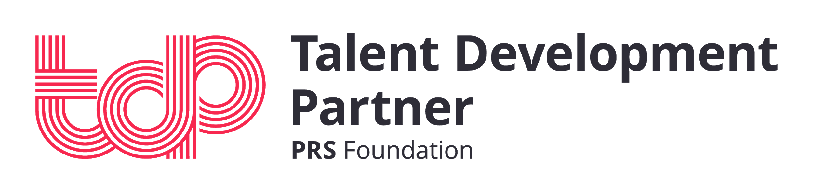

English Folk Dance and Song Society
2 Regent’s Park Road, London, NW1 7AY
020 7485 2206 ; www.efdss.org
Registered Charity 305999; Company Limited by Guarantee 297142; VAT No. 233 8664 49

