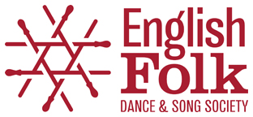

Dance Mini Grants
Increasing Engagement in Folk Dance

Application Form

Name
Group / organisation name (if applicable)
Contact address
Postcode
Telephone
Email
Website/social media links

1) Tell us briefly about yourself and / or your group (if applicable) [Up to 150 words]

2) Briefly describe the project or event/s you want to spend your Mini Grant on? What do you want to do and why you want to do it? [Up to 300 words]

3) How much money are you requesting (maximum £500) and what will you spend it on? [Up to 60 words]

4) How will your project or event engage more people / a wider range of people, in folk dance? [Up to 150 words]

5) How will your project or event ensure a safe and positive experience for all? (In reference to Safeguarding and Risk Assessment etc) [Up to 150 words]

6) How will your project or event maximise participation by people from a diverse variety of backgrounds and needs? (In relation to one or more of: age, disability, gender reassignment, marriage and civil partnership, pregnancy and maternity, race, religion or belief, sex, sexual orientation, and social or economic status)? [Up to 150 words]

Completed application forms should be emailed by 5pm, Monday 10 November 2025 to: Jen Cox, Dance Development Manager, dancedevelopment@efdss.org

Applicants will be informed of the outcome of their application by Thursday 20 November 2025.

The mini grant must be used, and project delivered, by 31 July 2026.

The final report on the activity must be submitted by 8 September 2026.

For further information, see: https://www.efdss.org/about-us/what-we-do/news/15479-dance-mini-grants-2025

