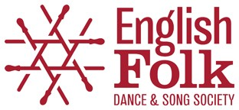
October 2021
MICRO GRANTS FOR PROFESSIONAL FOLK ARTISTS
Thanks to donations we are delighted to announce this new fund of Micro Grants for Professional Folk Artists who live and work in England.
Six grants of £500 each are being offered to folk artists to support anything that will help their professional career development. This could be:
- • Time to develop creative projects
- • Support for the production of new albums
- • Instrument purchase
- • Technical equipment purchase (eg portable sound equipment)
- • Other training and development activities (including courses)
This list is not exhaustive
Applicants can be at any stage of their career but must be working as a professional artist in the folk arts (eg music, dance, storytelling). Applications will be accepted from individuals and groups of artists. The maximum award to each successful application will be £500 regardless of the number of artists involved in the application.
Grants must be used by 30 June 2022.
Applicants must complete the accompanying application form and return via email (if this is problematic, please contact us).
The closing date for completed application is the 29 November 2021. All applicants will be informed of the outcome of their application by 10 December 2021.
For queries, please contact katy@efdss.org or zoe@efdss.org
English Folk Dance and Song Society
2 Regent’s Park Road, London, NW1 7AY
020 7485 2206 ; www.efdss.org
Registered Charity 305999; Company Limited by Guarantee 297142; VAT No. 233 8664 49

